

**Podiatric Medicine and Surgery**

**Student Clerkship Handbook**

**2025-2026**

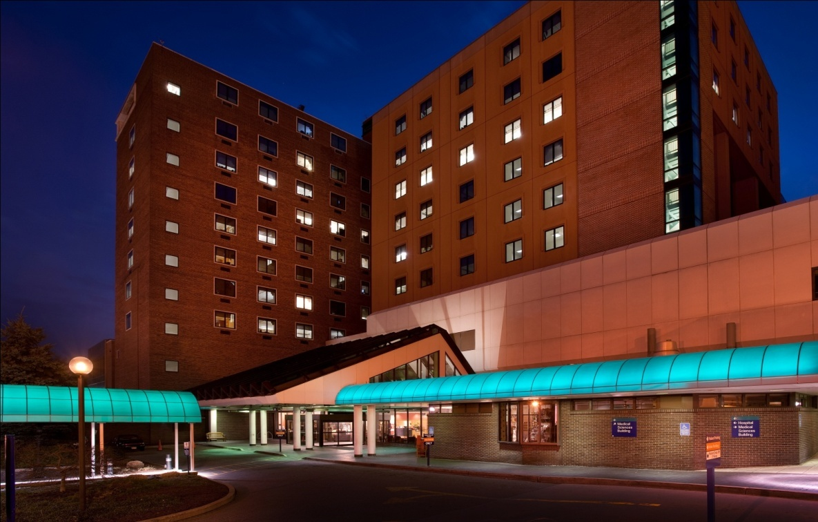



**Podiatry Student Handbook**

**Department of Podiatric Surgery**

Dear Student:

Congratulations and Welcome!

It is our pleasure to welcome you to the Podiatric Medicine and Surgery Residency Program at UPMC ME Harrisburg. We know that this will be an exciting and rewarding part of your podiatric medical education. In preparation for your rotation at UPMC Harrisburg, we have included some informational material for you to review prior to your arrival.

As an integral part of the education, you will receive at UPMC Harrisburg, it is expected that you will actively participate as a member of the residency team. This includes but is not limited to clinics, patient rounds, emergency calls, journal club, radiology rounds, lectures, and workshops at our skills lab. During the month, you will be expected to participate in at least one weekend of call and present a short lecture/presentation to our residents and myself on an interesting case or subject that you encountered during your time here.

The externship will begin based on the National Clerkship Calendar provided by CPME calendar, which can be found by visiting. [www.aacpm.org](http://www.aacpm.org) (please note that various month's rotations do not necessarily commence at the first of the month). You will meet with the Program Manager at the UPMC Harrisburg Brady Building 205 S Front Street, Harrisburg, PA 17104, on the morning of your first day. Designated parking is covered on page 6.

Enjoy your experience!

Jeffrey A Marks, DPM

Associate Program Director

**UPMC ME Harrisburg Podiatric Medicine and Surgery Resident Team**

|  |  |  |
| --- | --- | --- |
| **Name** | **Cell Phone** | **Email** |
| Isaiah Tates PGY-3 | 806-543-1291 | Isaiahtates4@gmail.com |
| Ravneet Gill PGY-3 | 646-258-0432 | Ravneetg12@gmail.com |
| Antonio Sierra PGY-3 | 727-858-7429 | Antoniosierra2203@gmail.com |
| Kaitlyn Fox-PGY-2 | 717-634-4659 | Foxkm52312@gmail.com |
| Lauren Adkins-PGY-2 | 352-401-2104 | Laurenadkins0812@gmail.com |
| Tulsi Menaria-PGY-1 | 502-379-7985 | Zucchenna@gmail.com |
| Virti Shah-PGY-1 | 201-912-0337 | Virtishah2696@gmail.com |

**Daniel Yarmel, DPM, FACFAS Jeffrey A. Marks, DPM, FACFAS** Program Director Associate Program/Clerkship Director

Podiatric Medicine and Surgery Residency Program UPMC ME Harrisburg

UPMC ME Harrisburg Email: footjmarks@verizon.net

Email: [footdoc1@gmail.com](mailto:vnookala@pinnaclehealth.org) Cell: 717-580-1862

Cell: 717-724-7056

**Kim Miller**

ME Training Program Department Manager

Podiatric Medicine and Surgery Residency

and Clerkship

Brady Hall 902

205 South Front Street

Harrisburg PA 17104

Phone: 717-231-8429

Fax: 717-231-8756

[millerka18@upmc.edu](mailto:ebersoletl@upmc.edu)

**James Cleckner**

UPMC ME Harrisburg

Education Project Specialist

(Student Housing Contact)

Brady Hall 906

717-231-8724

[clerknerjt@upmc.edu](mailto:clerknerjt@upmc.edu)

***Course Title:*** Podiatric Surgery Clerkship

***Duration:*** 4-5 Weeks (depending on clerkship month) 1-2 Students/rotation

***Clerkship Director:*** Jeffrey A Marks, DPM FACFAS

***Location:*** UPMC Harrisburg

Podiatric Medicine and Surgery Residency Department

Brady Hall, #902

205 S. Front Street

Harrisburg, PA 17104

***Evaluator:*** Clerkship Director

***Evaluation Process:*** Direct observation of student participation and attendance on rounds, patient care, medical knowledge, practice-based learning and improvement, interpersonal and communication skills, professionalism, and including your podiatric medical school’s guidelines.

***Course Specific Goals***

***& Objectives:*** Provide exposure to various podiatric residency daily duties. This will include our clinics, patient rounds, emergency calls, journal club, radiology rounds, lectures, and workshops at our skills lab. We hope this is a “hands on” experience. The student, under direct supervision of our residents and attendings, will actively participate in the care and evaluation of private and clinic patients.

***Students report to:*** Clerkship Director –Jeffrey A Marks, DPM FACFAS

[footjmarks@verizon.net](mailto:footdoc1@gmail.com)

Clerkship Manager***-*** Kim Miller

[millerka18@upmc.edu](mailto:millerka18@upmc.edu)

**Program Overview**

As our podiatric surgical extern for the month, you will report to our second-year residents on podiatry service. The extern will assist with the history and physicals, case presentations, and chart review.

There will be opportunities for participation in our skills lab/cadaver lab during various months and the extern will be under the guidance of both the surgical resident and various podiatric attendings.

Basic competency in suturing and hand-ties is recommended prior to the month of externship. It is mandatory that an extern functioning with the podiatric surgical resident follows assigned hospital procedures and protocols diligently. During your first week, you will be required to attend a surgical scrub in protocol before you can scrub into a case.

The role of the Podiatric Surgery Service is unique at UPMC Harrisburg, Community Osteopathic and West shore Hospitals, in that the residents function intimately in several different departments including General and Vascular Surgery, Radiology, Infectious Disease, Internal Medicine and some outside clinics.

**Program Objectives**

1. Become familiar with hospital procedures and protocol.
2. Become familiar with the roles and responsibilities of other medical disciplines and their relationship with the Podiatric Surgical Service.
3. Become familiar with the pre-operative evaluation of the surgical patient and post-operative management.
4. Become familiar with the management of hospitalized non-surgical patients.
5. Become competent with podiatric surgical “History and Physicals.”
6. Become familiar and comfortable with the operative setting and instrumentation.
7. Allow the podiatric extern to begin to refine his/her surgical skills and identify any deficiencies.
8. Prepare the podiatric extern for post-graduate training as a podiatric surgical resident.

**Daily Duties and Academic Activities**

**Daily Schedule**

* The schedule varies daily depending on the number of surgical cases, inpatients in the hospital, and clinics to cover. Externs will be provided with a daily schedule from the chief resident. Residents will help externs settle into the rhythm of the service and are always available to answer questions.

**Inpatient Rounds**

* Externs will be expected to pre-round on the patient before rounds with the resident. Pre-rounds consist of looking up the patient's daily labs/vitals and having the dressing supplies prepared for each patient assigned.
* For new floor consults, externs will be expected to perform a history and physical and then perform a formal presentation with assessment and plan to the resident. Residents will guide externs on what is expected from a presentation and provide feedback.
* During rounds, externs will be expected to actively participate by performing patient presentations and engaging discussion about patient management.
* Following rounds, externs will be expected to update the sign out. Residents will go over this process on the first day of the rotation.
* Externs will be expected to write student progress notes on occasion. These will be for practice purposes as they are not part of the medical record but will be reviewed with the residents in order to provide feedback on quality, clarity, and plan development.

**Operating Room**

* Externs are expected to help prepare the OR prior to the case. Residents will show the extern where supplies can be found in the OR and what is expected prior to every case based on individual attending preferences.
* Externs should be prepared for the cases they are assigned to and will be expected to answer questions in the OR.
* Suture and hand tying skills are encouraged to be practiced prior to presenting for a case.

**Clinics**

* Externs will be assigned to attend both attending’s office clinics as well as Kline Clinic (the resident run clinic) throughout the month.
* Attendings will dictate the level of involvement of the extern in their offices.
* Externs will function like residents in Kline clinic and will be expected to interview, examine, create a plan, and execute any procedures deemed necessary under the supervision of the residents.

**Educational Activities**

* There is at least one educational activity per week. This includes journal club/radiology rounds, grand rounds, boards review presentations, and skill labs/cadaver labs/attending lectures.
* Externs will be made aware of all activities and are expected to actively participate. This includes being adequately prepared for the topics covered for journal club, boards review, etc.

**Extern Presentation**

* The extern will choose a presentation during their month rotation that directly involves a patient seen in the hospital or emergency department and/or during a surgical procedure. The presentation will be authorized by the chief resident and will be given during grand rounds if possible.

**Call**

* Externs will participate in one weekend of call and up to 3 days of weekday call, particularly trauma call days. Externs will accompany the resident on call for ED and floor calls and any add-on cases on their assigned call days.

**Professionalism**

* Externs should always be on time if not early.
* Externs are expected to be prepared and ask questions/clarification whenever needed.
* Externs should always present themselves in a kind, caring, professional manner.
* Externs should always respect each other, the residents, and the attendings. If there is an issue/conflict regarding another extern, resident, or attending, it should be reported to a chief resident first.
* If there is a concern/issue about an extern, it will be addressed directly to the extern by the resident or attending with the understanding that the externship director and residency director will be made aware of the situation. Discipline for unprofessional behavior will occur according to hospital policy.

Any questions regarding scheduling or details of the above should be directed to the resident team. Residents are always reachable by their cell phones and are happy to answer any questions.

**Attire:**

* Rounds and OR: Scrubs with white coat and closed toe shoes are acceptable for inpatient rounds. Residents will help externs obtain approved scrubs for the OR, but students will not be permitted to wear UPMC scrubs outside of the OR. Please plan to bring your own scrubs for daily activities.
* Clinics: Professional attire with white coat should be worn in the attending office clinics and the resident run clinic. Please, no open toe shoes.
* Student ID and access badges are to be worn at all times.

**Parking:**

Students that are NOT staying in the student house must park in the Cameron Street lot at 1000 Paxton Street, Harrisburg, PA 17104. Students **may not** park in the Residents Parking Lot or in the garages at Harrisburg. You will not have badge access to the other hospital parking lots. Security may fine you or tow your vehicle if you are parked in the wrong area.

Please note there is no gate in Cameron Street lots. You can enter and leave easily, but you will need to use the shuttle back and forth from the Mary Street entrance of the Brady Building. The shuttle typically runs every 10 to 15 minutes.

**Meals:**

Meals are not provided while you are on your clerkship rotation but may be available at grand rounds and other company-sponsored seminars. You are welcome to join our podiatry residents for breakfast and lunch at the hospital cafeterias or coffee shops.

**Library:**

The library is staffed from 9:00 am until 4:30 pm on the first floor of the Brady Building at UPMC Harrisburg Campus. Your hospital badge will allow you access.

**Absenteeism Policy**

There are no days off during clerkships. All academic and clinical assignments missed during an absence must be completed satisfactorily before academic credit can be awarded for the clerkship month. To be excused, absences that can be anticipated, e.g., on-going physician appointments that cannot be scheduled after hours, must be requested in writing, and approved by the course/clerkship director prior to the beginning of the clerkship. Requests for time off for observance of religious holidays must be submitted in writing at the beginning of the rotation; it is still the student’s responsibility to notify the clerkship director in advance of the rotation of their approved requested time off.

In case of an emergency or illness, the student should alert the resident they are assigned to for that day and the clerkship director of the situation.

**ABSENCES WITHOUT PRIOR NOTIFICATION OF THE FACULTY WILL BE CONSIDERED AS UNEXCUSED ABSENCES.**

**STUDENT EXPOSURE INSTRUCTIONS**

Students are assigned an Employee Safety CBL prior to starting their rotation. In this CBL they are instructed to report exposure immediately.

When they report an exposure, the students will be instructed to follow this process:

If you have been exposed to blood or body fluids due to a needle stick, cut, splash, or other incident:

1. **Immediately** following the exposure:

* **Needle sticks, cuts, or splashes to the skin** should be washed with soap and water.
* **Splashes to the nose and** mouth should be flushed with water.
* **Eyes** should be irrigated with water or saline.

2. **After** completing the treatment above, call the hospital operator to page the **Exposure Response Team** (ERT).

* In hospitals, **dial "0"**
* Outside of hospitals, **dial 717-782-3131**

3. **Wait** for the **Exposure Response Team** to contact you and give further instructions. You may need to place orders on the source patient, please be prepared to follow the instructions provided by the Exposure Response Team.

The Exposure Response Team handles **ONLY** exposures to possible bloodborne pathogens.

(The Exposure Response Team **DOES NOT** handle any other exposures to infectious diseases, ie. influenza, meningitis, scabies, etc. Contact the infectious disease on-call team for these and all other infectious disease exposures.)

*Once the ERT is notified, they will instruct the patient care provider to order the appropriate screening tests on the source patient. The results of this information will be provided to the students.*

*The student is instructed to seek medical evaluation immediately. Students should check with their school to find out if the school has a policy as to where they are to go for evaluation.*

*Students can be seen by the UPMC Emergency Department but will be responsible for payment.*

**HOSPITALS:**

UPMC Harrisburg UPMC West Shore

111 S Front Street 1995 Technology Parkway

Harrisburg PA 17104 Mechanicsburg PA 17050

(717) 231-8900 (717) 791-2600

UPMC Community Osteopathic

4300 Londonderry Road

Harrisburg, PA 17109

(717) 652-3000

**CLINICS:**

Kline Clinic Wound Care Clinic

2501 N 3rd Street 4310 Londonderry Road, Suite 1A

Harrisburg PA 17110 Harrisburg PA 17110

(717) 782-2100 (717) 671-2050

**OFFICES:**

Jeffrey A. Marks, DPM

161 Old Schoolhouse Lane

Mechanicsburg PA 17055

(717) 697-7602

Harrisburg Foot & Ankle

Dan Yarmel, DPM / Amber Treaster-Yarmel, DPM / Matthew Rien, DPM

4033 Linglestown Road, Suite 1

Harrisburg PA 17112

(717) 651-0000

Cumberland Foot & Ankle Specialists

Susan Rosso, DPM / Anthony Luzzi, DPM

5148 East Trindle Road

Mechanicsburg PA 17050

(717) 761-3161

Orthopedic Institute of PA

Nicholas Amalfetano, DPM

3399 Trindle Road

Camp Hill, PA 17011

(717) 761-5530