RESIDENT POLICY AND PROCEDURE MANUAL

Podiatric Medicine and Surgery Residency with Reconstructive Rearfoot/Ankle Surgery Credential
2025

Kaiser Foundation Hospital
Santa Clara, California

THIS HANDBOOK IS THE PROPERTY OF KAISER SANTA CLARA FOOT AND ANKLE RESIDENCY PROGRAM AND SHOULD NOT BE COPIED WITHOUT THE EXPRESS PERMISSION OF THE PROGRAM DIRECTOR.

THIS MANUAL IS DESIGNED TO BE USED IN CONJUNCTION WITH THE KFH RESIDENT POLICY AND PROCEDURE MANUAL OF THE NORTHERN CALIFORNIA REGION RESIDENCY TRAINING PROGRAMS WHICH IS DELIVERED TO THE RESIDENT DURING ORIENTATION AND IS STORED ON MEDTRICS

Program Director: Cristian Neagu, D.P.M.
Site Director: Jessica Lickiss D.P.M.

TABLE OF CONTENTS

COVER PAGE 1
TABLE OF CONTENTS 2
GOALS AND OBJECTIVES 3
INTRODUCTION TO GOALS 3
INTRODUCTION TO OBJECTIVES & TASK ACTIVITIES 3
7 CORE COMPETENCIES 3
COMPETENCIES/ROTATIONAL GOALS & OBJECTIVES 4
PODIATRIC SURGERY ROTATION 4
PROCEDURES FOR PMSR/RRA 4
CASE ACTIVITIES 4
PROCEDURE ACTIVITIES 4
DELINEATION OF PROCEDURE FOR YEARS OF TRAINING 4
FIRST YEAR RESIDENT-ROUTINE FOREFOOT & MIDFOOT SURGERY 4
SECOND YEAR RESIDENT-COMPLEX FOREFOOT SURGERY 5
ROUTINE REARFOOT SURGERY 5
THIRD YEAR RESIDENT_COMPLEX REARFOOT & ANKLE RECONSTRUCTION & TRAUMA 5
LEARNING ACTIVITIES 5
PODIATRIC CLINIC ROTATION 5-6
GENERAL GOALS & OBJECTIVES 6-7
PROTOCOLS 7
Preoperative 7
Postoperative & Medical Patients 7
Policy on Order Writing 7
Postoperative Discharge Rounds 7
Weekend Rounds 7
Consultations 8
ADMISSIONS OF PATIENTS TO THE HOSPITAL 8
SURGICAL PATIENTS 8
OPERATING ROOM POLICY FOR RESIDENTS 9
CLINIC 9
RESIDENT REQUIREMENTS 9
HOSPITAL PROTOCOL 9-10
DIDACTIC ACTIVITIES 10
Resident Teaching Time 10
Case Review & Radiology Rounds 10
Journal Club 10
Text Review 10
Vascular Rounds 10
HAYWARD/FREMONT DIDACTIC ACTIVITIES 10
Journal Club & Radiology Rounds 10
Resident Teaching Time 11
First Year Resident 11
PROCEDURE SUPERVISION GUIDELINES FOR RESIDENTS 11
Procedure Supervision Table 11
PODIATRY RESIDENTS ON-CALL POLICY WHEN ON PODIATRY SERVICE 12
POLICY FOR SUPERVISION OF PODIATRY RESIDENTS & MEDICAL STUDENTS 12
PODIATRIC RESIDENTS ON-CALL EXPECTATIONS FOR ANKLE FRACTURES 12
POLICY FOR PODIATRIC EXTERNS 13
VISITING MEDICAL STUDENTS FROM PODIATRIC MEDICAL SCHOOLS 13
REMEDIATION POLICY 13
RESIDENT ACADEMIC AND PROFESSIONAL APPEAL PROCESSES 13
RESIDENCY MASTER SCHEDULE 14-15
CPME WEB SITE 320/330 15
REMEDIATION/APPEAL……………………………………………………………………………………………………..
COMMUNICATION…………………………………………………………………………………………………………..
ELECTRONIC DEVICES………………………………………………………………………………………………………
PATIENT PRIVACY RULES………………………………………………………………………………………………….
HIPPA AND SOCIAL MEDIA…………………………………………………………………………………………………
SCHEDULE CHANGES……………………………………………………………………………………………………….
ACADEMIC SCHEDULE……………………………………………………………………………………………………..
COMPETENCIES ………………………………………………………………………………………………………………..

Goals and Objectives

- Introduction to Goals:

- Prepare the Podiatry Residents for hospital practice, medically, surgically, and interprofessional.
- Intensive clinical experience in the above-mentioned areas that will allow the graduating resident to practice competently as a primary care Podiatrist and as a Foot and Ankle Surgeon.
- Adequately prepare for diplomat status of the American Board of Podiatric Surgery and the ABPOPPM
- The development of attitudes and habits that will lead to lifelong learning.

- Introduction to Objectives and Task Activities:

- The resident will achieve the above goals through a series of rotations. These will include Podiatric Medicine and Surgery Clinic, Orthopedic Surgery, Vascular Surgery, Plastic and General Surgery, Emergency Room, Internal Medicine, Anesthesia, Pathology, Infectious Disease, Rheumatology, Behavioral Science and Radiology. Each of these rotations curriculums is located in podiatric residency resource.

C. 7 Core Competencies

- Prevent, diagnose, and manage diseases, disorders, and injuries
of the pediatric and adult lower extremity.

2. Assess and manage the patient’s general medical status.

- Practice with professionalism, compassion, and concern in a
legal, ethical, and moral fashion.

4. Communicate effectively and function in a multi-disciplinary
setting.

- Manage individuals and populations in a variety of socioeconomic
and healthcare settings.

- Understand podiatric practice management in a multitude
of healthcare delivery settings.

- Be professionally inquisitive, life-long learners and teachers
utilizing research, scholarly activity, and information technologies
to enhance professional knowledge and clinical practice.

Competencies/Rotational Goals and Objectives:

Competencies for all rotations including podiatric surgery are available for review in Medtrics.

Podiatric Surgery Rotation

Objective:

The resident will be able to demonstrate proficiency in common surgical procedures of the foot and ankle and understand the appropriate indications, contraindications, and perioperative management of these patients. The resident will obtain the necessary cases to fulfill requirements for the American Board of Podiatric Surgery.

Delineation of procedures for year of training

First Year Resident - Routine Forefoot and Midfoot Surgery
Inc: Bunion Correction
Hammertoe Correction
Neuroma Excision
Excision of simple soft tissue masses and cysts
Exostectomies
ORIF of simple forefoot Fractures
Simple repairs of tendon and soft tissue trauma
Forefoot Amputations
EPF
Simple tendon transfers
Second Year Resident – Complex Forefoot Surgery

Inc: Revision of failed routine forefoot and midfoot surgery
Complex forefoot surgery and trauma
Complex forefoot reconstruction

Routine Rearfoot Surgery:

Inc: Tarsal Osteotomies
Simple Rearfoot Fusions

Noncomplex rearfoot Trauma

Third Year Resident - Complex Rearfoot and Ankle Reconstruction and trauma

Inc: Ankle and rearfoot ORIF,
Triple Arthrodesis, Ankle fusion, complex reafoot fusions
Pediatric reconstructive surgery (clubfoot, Equinus, Vertical
Talus, Calcaneal Valgus)
Neuromuscular Disorder Reconstruction (Tendon Transfers, Osteotomies, Fusions)

*On Call Resident will assist the on call Attending Surgeon (Orthopedic or Podiatric)
on all urgent procedures irrespective of level of training or level of difficulty

Learning Activities:

- Demonstrate surgical proficiency in the following surgical categories:
Soft Tissue Surgery
Digital Surgery
Lesser Metatarsal Surgery
First Metatarsal Surgery
Rear Foot-Ankle Surgery
- Sterile technique in the operating room
- Complete understanding of risks, complications, indications, and alternate treatments to all foot and ankle procedures.
- Assist podiatric and orthopedic surgeons
- Will complete logging of surgical cases no later than a week following completion of surgery

Proper Logging of Surgical Procedures

Website: https://www.podiatryrr.com/Login
Guide to Logging: https://www.cpme.org/files/CPME/Proper%20Logging%20Guide%20-%20June%202018.pdf

You are required to document and log your residency training on Podiatry Residency Resource. Both the residency director and the CPME review your logs regularly, and it is important that case numbers in all areas show consistency amongst the residents and over time. Case logs are a critical component of the documentation of resident training and the accreditation of the program. For nonsurgical evaluation, there is emphasis is placed surgical procedures and on Complete H&Ps and Biomechanical Cases. You will NOT graduate from the program if your logs are incomplete and do not meet all the case log numbers and diversity requirements. Dr. Neagu will review your logs monthly and discuss your progress in all areas during your Biannual Evaluation meeting.

Complete H&P
In order to qualify as a complete H&P, full documentation of a complete physical exam is required. Ideally, plan to log all complete H&P’s in your first year rotations, so they are supervised by MDs/ DO and the supervising physician should be clearly documented. Only a percentage of H&Ps obtained on medicine (non podiatry service) qualify for the logging requirement.

Biomechanics
Biomechanical cases must be completed on an ongoing basis. You must use the full biomechanical evaluation template embedded in KPHC for the case to count.

Non-Podiatry Rotation Logs
You must document your training in some way in every rotation; try to log something in PRR every day. ER, Internal Medicine, Infectious Disease inpatient cases can all contribute to your Comprehensive H&Ps. All General surgery, Vascular surgery, Orthopedic surgery cases that you scrub in the OR are to be logged under their appropriate category. Please keep a simple activity log recording what you saw and what you learned is required for rotations outside of podiatry. PRR functionality exists for each rotation type. Further details will be included in your ongoing training.

Surgical Case Logs
Surgical case logs are critical to your training and must be maintained diligently. The general policy is that you log surgical cases on the same day as the cases are done. They are verified on at least on a monthly basis by Dr. Neagu. Residents who delay logging always have lower numbers by the end of their training. You will receive reminder emails/texts from Dr. Neagu if your logs are not current when she verifies them. Ongoing failure to maintain logs may result in corrective action and will certainly be documented in your Training Folder/Binder.

Common Pitfalls

Fragmentation/Unbundling (Refer to PRR for further information/explanation)
This is when you take a surgery and make multiple procedures out of it. Generally, you can avoid this by applying the “One Incision – One Procedure” Rule. The opposite is not true – An ankle ORIF with 2 incisions is still only one procedure. A triple arthrodesis is one procedure. A pan metatarsal head resection with a fusion of the 1st MTPJ, removal of met heads 2-5 and hammertoe corrections across the board is 2 procedures – the first ray fusion and the pan met.

Splitting, which is the breakdown of a single surgery into multiple procedures, is in an attempt to show more surgical activity. The general rule is that there is only one procedure per incision. For example, a Lapidus bunionectomy with a bicorrectional osteotomy and an Akin is all done through one incision and should be logged as a single procedure; a pan metatarsal head resection done through 5 incisions is 5 procedures.

Bundling involves multiple residents claiming “2nd assist” activity on the same surgery. It is very easy for the CPME to check for this so whenever there is a question either ask your fellow resident or the attending involved. Generally, the resident who dictated the operative report is likely the resident who should receive primary assist activity.

Logging Recommendations
- You should keep up on your logs by getting in a daily habit. When you are in the OR for the day, consider logging your cases before you even return to your office or between cases.
- Log something in every rotation that has patient contact: during your first year - you should log your H&Ps while on Internal Medicine, Infectious Disease, and Emergency Department.
- Pediatric foot and ankle cases can be either clinic or surgical
- You must use the complete Biomechanical evaluation form (in electronic files packet/dot phrase) in Health Connect if you log a biomechanics case.

VOLUME AND DIVERSITY REQUIREMENTS:
They are listed in CPME 320 and appended below (as of 7/1/23 updates)

Case Category | Number Required
Total Foot & Ankle Cases (PMSR/RRA) | 300
Podopediatric cases | 25
Biomechanical cases | 50
Comprehensive medical H&P examinations | 50
Other podiatric Procedures | 100
Lower extremity wound care | 50
Trauma cases | 50
Procedures
Total 1st and 2nd assist | 400
1st assist | 80
Digital | 80
First Ray | 60
Other Soft Tissue Foot Surgery | 45
Other Osseous Foot Surgery | 40
Reconstructive Rearfoot/Ankle | 50

SURGICAL PROCEDURE CATEGORIES AND CODE NUMBERS

Podiatric Clinic Rotation

Objectives:

The resident will be able to diagnose and treat common foot disorders in the pediatric and adult outpatient clinic. The resident will be able to determine when a patient needs to be admitted to the hospital and will be able to admit the patient and institute appropriate treatment.

The resident will have scheduled consisting of one the following:
1. Clinic (resident is assigned to an attending clinic)
2. On call schedule with on-call attending
3. OR schedule.
The residents will be supervised by an attending podiatrist while in clinic at all times. In GSSA the supervising attending will have either a RSP (resident supervision profile) or the PCON schedule. The residents will present the patient to the attending and the attending will see the patient with the resident. The clinic and OR schedule is published monthly and will be distributed 2-3 months in advance.

Learning objectives:

- Required attendance at regularly scheduled podiatry meetings.
- Complete peri-operative management: H&P, clinical, biomechanical, radiographic, laboratory, and medical work-up.
- Management of outpatient clinic approximately 20 to 30 patients a day, approximately three days a week.
- Required attendance at weekly Grand Rounds for Podiatry and combined Orthopedics and Podiatry.
- Will be on-call approximately every third night and every third weekend for the management of the hospitalized inpatient podiatry patients and for management of foot and ankle trauma and infections coming through the Emergency Room. Will complete the medical history and physical examination on all preoperative and admitted podiatry patients.
- Attend required lectures.
- Participation in monthly Podiatry Journal Club.
- Complete logging of surgical cases on a weekly basis.
- Lecture in a formal setting to diabetic patients regarding diabetic foot care as needed.
- The podiatry resident will make hospital rounds on all hospitalized podiatry patients twice daily when on call.
- Submit a research proposal.
- Develop and execute an original research project, culminating in at least one manuscript of publishable quality.
- Familiarity with and understanding of the principles and approaches to office practice management and patient management.

General Goals and Objectives:

- Be able to treat trauma of the foot and ankle: This includes fractures and other acute forms of trauma involving the foot and ankle joint (i.e. talus, calcaneal fracture, Lisfranc fracture dislocations, metatarsal fracture, crush injury, burns, malleolus and plafond fracture).
- Increased role in patient care responsibility and decision making each residency year, will progressively have a greater role in determining the particular type of clinical care, postoperative management and surgery
- Teaching responsibilities: A Third-year resident will be a Chief Resident and will have PGY 1 and PGY 2 Kaiser Podiatry residents as well as medical students below him. The Third-year podiatry residents will have increased responsibility to teach the first- and second-year residents and advise them on matters regarding both inpatient and outpatient Podiatry patients.
- The Third-year resident will have the opportunity (pending approval of the attending) to perform surgery on any scheduled podiatric surgical case they feel that they need further experience in preference to the first- and second-year residents.
.

Protocols
- Rounds:
- Preoperative - All preoperative podiatric surgical patients will have rounds and appropriate preoperative notes and consent forms entered in the hospital chart prior to the residents leaving the evening before the surgery. This includes Sunday night for those patients to be operated on Monday morning unless alternative arrangements have been made with the staff podiatrist on-call. Any discrepancies in the preoperative laboratory evaluation, radiographs, or physical examination will be noted and the admitting podiatrist or physician will be notified. If attending cannot be notified, the house physician will be notified to concur with the orders given by the resident.

- Postoperative and Medical Patients - Rounds on all postoperative and medical patients will be made prior to 8:30 a.m. each morning so that any abnormal findings will be reported to the admitting attending or the attending on-call that morning. Any patient in serious or critical condition with abnormal laboratory findings or failure to demonstrate significant progress must have rounds made twice a day; this is, prior to 8:30 a.m. and before leaving that evening. Appropriate notes will be entered in the Electronic hospital chart.

c. Policy on Order Writing: Residents can write orders for all pre- hospital medicines the patient is taking. The podiatric resident is the primary care giver of in-patients on the podiatric service and routinely writes in-patient orders. In addition, residents can write standard sliding scale insulin orders and standard pre-operative insulin adjustments that relate to surgery and NPO status. Any non-podiatric related medicine orders or changes must be done by or in conjunction with a PCP or HBS physician. All orders must be dated, timed and stamped on each page.

Residents may give verbal orders. They are required to sign these within 48 hours of giving the order (preferably within 24 hours).

d. Postoperative Discharge Rounds - Patients who undergo outpatient surgery
must have postoperative rounds before discharge to home. At this time, final instructions and evaluation of postoperative x-rays will be done. This will be the responsibility of the resident assigned to the surgical case unless otherwise arranged with the on-call resident or staff podiatrist. All discrepancies noted on the postoperative x-rays will be brought to the attention of the staff podiatrist before discharge.

- Weekend Rounds - It will be the resident's responsibility to make rounds at least once each day on the weekend. This will be arranged with the attending on second or first call. He/she will avail themselves of the recent progress of each patient to be attended during the weekend times.

- Consultations – All urgent consultations from other medical departments shall be handled in conjunction with the attending podiatrist by the resident on call the day the consult is received. If the consult is taken after clinic hours, the resident will not schedule the patient to be seen the next clinic day unless prior arrangements are made with the on-call person, or they will present to receive the patient.

  - All consultations will be verbally (and/or via secure text) discussed with attending on call
  - Resident will clearly communicate whether the patient was physically seen or not
  - Prior to discussion with attending on call, resident will be familiar with the following:
    - Patient HPI
    - Patient medical history
    - Patient allergies
    - Patient active medications and association to PMH
    - Active or pending laboratory studies
    - Radiographic studies
    - Previous surgical history
    - Patient social history (employment, marriage, stairs at home, etc)
    - Formulate a diagnosis
    - Formulate a clinical or surgical plan

NOTE- ALL CONSULT PATIENTS REFERRED TO PODIATRY DEPARTMENT THROUGH THE ON CALL RESIDENT NEED TO BE PHYSICALLY SEEN UNLESS THE ATTENDING ON CALL MAKES OTHER ARRANGEMENTS

NOTE: Consultations received from the Emergency Department that will require a clinic follow up appointment will NOT need a formal consultation request to be sent to the clinic. The resident will obtain the patient MR # and manage clinic follow up following discussion with the attending on call.

All In-patient Chart Notes are either to be completed by an Attending or Co-signed by an attending.

- Admissions of Patients to the Hospital:
- Patients will be admitted for all cases to undergo surgery with the attending podiatrist of that day. Direct, surgical, medical admission or emergency room admissions will be made concomitantly with the attending podiatrist and the officer of the day from the medical service. Co-admission must be entered in the hospital chart in written form at the time of patient's admission. The resident is to admit no surgical patient under his/her own name. The resident will maintain primary responsibility of outpatients with the concurrence of the attending podiatrist.
- All patients being discharged from the Podiatry service must have a discharge summary in standard form within 24 hours of their discharge. For those patients who had hospital stay of 48 hours or less, a short stay summary may be substituted. This should be in problem-based format and include all discharge medications, consultations while an inpatient and scheduled outpatient appointment.
- The discharge summary should include the following information in a problem based and organized manner:
- Date of admission and date of discharge
- Hospital course by problem list (include cultures, antibiotics, surgeries, clinical progress, medications, changes in treatment with associated rationale)
- Discharge plan and follow up

- Surgical Patients:
- Preoperative Laboratory Examinations: All pre-op labs are to be determined based on medical history of patient.
- Co-Admission: All surgical a.m. admission patients will have preoperative evaluation by the medical staff, as well as the podiatry resident in conjunction with the staff podiatrist. It is the resident's responsibility to make sure the proper documentation is in complete form on the chart.
- Preoperative medical evaluation is not necessary on Outpatient Surgery patients unless specified by the attending podiatrist, as it is provided by the Anesthesiology Department.
- Dictation: The resident shall be responsible for all postoperative dictation on surgery, which he/she has scrubbed. The resident will dictate the attending as the surgeon and the resident as the Co or assistant surgeon. Dictation will be completed within 24 hours.
- Consent: All patients undergoing minor surgery, outpatient surgery, and same day stay surgery, in addition to patients having procedures in the clinic and ER, shall have written consent with proper witness. Consent should include the following information:
- Correct anatomic location
- Correct explanation of surgical procedure in layman’s terms as well as medical terminology (ie- correction of the LEFT bunion with bone cuts, screws and plates as needed/distal metatarsal osteotomy)

- Operating Room Policy for Residents:
- All resident surgeons must be hospital staff members.
- A resident may assist an attending surgeon by performing part of the surgery with the attending surgeon being physically present in the OR. The attending must be present in the hospital building and available until the patient has left the OR (ie- splint application)
- Resident Responsibilities in the OR:
- Ensure that consent is present, filled out, signed and lists the correct procedure and anatomic location prior to day of surgery.
- Ensure all necessary equipment is present prior to start of case.
- Ensure correct patient positioning.
- Tourniquet application and tourniquet pressure selection.
- Draw local anesthetics for block as needed.
- Be familiar with patient history, radiographs, indication for surgery and procedure selection.
- Be familiar with surgical approaches and techniques.
- Be present in the OR at least 15 minutes before the scheduled start time

NOTE: Degree of resident involvement in a case is directly dependent upon performance
of above-mentioned requirements.

- Clinic:
- The resident will be generally free to maintain independent judgment during clinic hours. Outpatient encounters will take place in a combined attending/resident clinic. Surgeries considered minor in nature (nail surgery, warts, etc.) will be under the discretion of the resident with the concurrence of the attending podiatrist. Before scheduling any inpatient surgery, the resident will seek consultation with an available podiatrist or the podiatrist on-call for that day. When an attending podiatrist is not in the clinic on a specific day, the resident will be responsible directly to the Chief of Orthopedics, having been arranged 48 hours in advance. The resident will seek consultation with the appropriate medical specialist and on all difficult or complicated cases the concurrence of the attending podiatrist.

- Resident Requirements:
- Residents will be required to complete a research project of publishable quality. He/She may feel free to use any resources and/or medical specialists at their disposal or at the invitation of that specialist.
- Residents will be required to present several short talks on selected topics at Podiatry and Orthopedic staff meetings. A schedule will be set for the year by the Chief Resident in conjunction with the Program Director, the staff, and the Chief of Podiatry.

- Hospital Protocol:
- Podiatry Residents shall avail themselves of a copy of the Bylaws, Rule, and Regulations of the Hospital, as well as the CQAS Standards of the Hospital and the standards and policies of the Department of Podiatry and Department of Orthopedics and be directly responsible for the same. Discrepancies in any of the above will be reported directly to the Chief of Podiatry, Program Director, Chief of Orthopedics, Chief of Staff, and Hospital Administrator.

DIDACTIC ACTIVITIES

Didactic activities take place in both Santa Clara and GSAA and are listed in the master academic schedule. For exact dates and times, please consult the schedule.

Following completion of didactic activities, resident in charge will forward to GME, Program Residency Administrator a list consisting of topics reviewed and attendance list for uploading to Medtrics.

8. Residents Teaching Time

Residents Teaching Time

- All residents and externs will be required to attend and participate in all RTT
session even when on outside rotations (except Medicine).

b. RTT can include Lectures, Workshops, Cadaver dissections; guest lectures,
c. Problem patient clinic will also take place during this teaching time and needs
to be scheduled in advance and placed on the sign-up sheet in Resident’s Office.

Case Review and Radiology Rounds

This will be held each month from. This activity is mandatory. Have interesting/difficult cases ready to present and discuss. Chief resident will be responsible for ensuring appropriate cases to present.

Journal Club
Monthly Journal clubs will be scheduled on Monday during protected academic time from 12:00–1:30 pm. Journal articles will be selected by faculty from specific journals and submitted to all residents in advance. Conference room and lunches need to be arranged and confirmed in advance as well.

Text Review

Will encompass review of assigned textbook chapters.

Vascular Rounds
Vascular and Podiatry joint rounds will take place as scheduled. Attendance is required.

9. Procedure Supervision Guidelines for Residents

- Attending Physician is present while procedure is being performed.
- Attending Physician is consulted before procedure is performed but does not have to be present during procedure.
- The procedure may be performed independently while under the direct and indirect general supervision of the residency program.

All procedures performed in the operating room must be performed with an attending present.

Procedures performed while on non-podiatric rotations will be under the direction of the supervising attending for that rotation.

Procedures Year 1 2 3
Operating room procedures 1 1 1
Closed reduction of digital and metatarsal fractures 2 2 3
Closed reduction of midfoot and rearfoot fractures 2 2 2
Closed reduction of forefoot dislocations 2 3 3

Closed reduction of midfoot and rearfoot dislocations 2 2 2

Foreign body removal 2 3 3
Suturing of lacerations Skin 3 3 3

Tendons 2 3 3
Incision and drainage of foot infections – Bedside 3 3 3
Injections to foot 3 3 3
Matrixectomies 3 3 3
Compartment pressure measurements 3 3 3
Admitting patients to hospital 2 2 3
Consultations 2 3 3
wound debridement 3 3 3

Patient care orders 3 3 3

Excision of simple skin lesions 2 3 3
Aspiration of joints or cysts 3 3 3
Debridement of corns, callouses, and toenails 3 3 3
Conscious sedation * 2 2 2

* In consultation with attending on premise.

Podiatry Residents On-Call Policy when on Podiatry Service

When a podiatry resident is on the podiatry service, his/her primary on-call responsibilities are for podiatry issues. The podiatry resident will take back up call for orthopedics as surgical assist when needed only after they have fulfilled their podiatric duties (Clinic, Night classes, Hospital rounds, Admits, ER, and Evening podiatric surgery). The resident cannot assist orthopedics on non-podiatric surgical cases if it exceeds duty hour restrictions for residents. The On-call resident will be on-call for both podiatry and orthopedics for all foot and ankle related issues 24 hours a day. Orthopedics back-up call does NOT include admissions, or ER call for non-podiatric issues. Podiatry resident will be available on-call for all orthopedic issues when on the orthopedic service during their orthopedic rotation as defined by the goals and objectives for that rotation.

* Podiatric responsibilities always over-ride Ortho assist unless resident is on
Ortho rotation.

SUPERVISION

Policy for Supervision of Podiatry Residents and Medical Students:

The Kaiser Santa Clara podiatry residents will have a COMBINED clinic schedules in the same physical clinic as the attending podiatrists. The residents will have full access to Health connect and will be able to sign their own clinic charts with associated co signature by an attending. The On Call podiatric attending will act as the assigned clinical supervisor for all the residents on the day he/or she is on call. Patients seen by the resident who have an established attending assigned to them should be managed with that attending. If the attending co-managing a patient with the resident is not available, then the On Call supervising attending will be responsible for encounters needing assistance by the resident. Prescriptions written by residents without a DEA license will be automatically assigned (by the pharmacy) to the attending on call that day.

Residents on call will have a shared clinic schedule with the on call attending while the residents who are not on call will be assigned to attending in clinic.

RE: Podiatric Residents On-Call Expectations for Ankle Fractures

The podiatric resident, when on-call, will be expected to be available to handle all ankle fractures. This includes being available for both Orthopedics and Podiatry to admit, assist in surgery, and follow-up for ankle ORIFs. Aside from surgically assisting on orthopedic cases the on-call resident’s responsibilities do not include admitting or managing on-call orthopedic issues unrelated to the ankle or foot unless the resident is on the orthopedic rotation. The resident’s normal responsibilities (Clinic and in- patient management) may on occasion conflict with their ability to either admit or assist surgically on a particular ankle or Ortho case. Any conflicts between the orthopedic surgeon and the podiatry resident should be handled amongst the orthopedic surgeon and the podiatry attending on-call that day.

Policy for Podiatric Externs:

The Podiatric externs will be primarily accountable to the on call attending staff podiatric surgeon or staff attending scheduled with on each day of the rotation. All office based surgical procedures i.e.: (Toenail procedures, wound debridement, etc.) must be performed under the supervision of an attending. Externs may question and examine patients under the supervision of the resident but cannot perform office based surgical procedures under the supervision of the resident. Externs must get permission from the attending to assist in the operating room. They need to be available to return to the clinic at any time the on-call attending deems necessary.

Visiting Students from Podiatric Medical Schools:

Students from the various Podiatry Medical School visiting the Kaiser Permanente Santa Clara Program will not be allowed to participate in any direct patient care. They are here for observational purposes only and will be allowed to observe in the clinic with the attending podiatric surgeon and/or resident. Visiting students generally will visit for a portion of a day with the purpose of observing and determining the appropriateness of the program for their needs and have questions answered pertaining to the Kaiser Santa Clara Residency program.

RESIDENCY AND REGIONAL MANUALS

In addition to above rules and regulations, each resident will review the Kaiser Foundation Hospitals Residency and Fellowship Training Programs Policy and Procedure Manual. The manual is available by accessing the Kaiser Intranet under the department tab and listed undergraduate Medical Education.

Assessments: Please see the Evaluations section in Medtrics.

Remediation Policy

If a resident gets an unsatisfactory evaluation from a rotation the following will take place:

a. The resident may be required to repeat a part or all the rotation.
b. Additional reading may be assigned pertaining to the rotation and the resident give a presentation on this reading.
c. Resident may be assigned additional clinic time with the attending that gave the unsatisfactory evaluation.

The remediation is to be decided by the attending that gave the unsatisfactory evaluation and the program director. The remediation must be completed by no longer than within 3 months of completing the residency program. If not, the resident will be placed on probation until the assignment is complete and will not receive their residency certificate until the assignment is complete.

Resident Academic and Professional Appeal Processes

Please see Kaiser Foundation Hospital Residency & Fellowship Training Programs Policy and Procedure Manual available on Kaiser Permanente intranet under the Department tab and Graduate Medical Education- page 13 and Appendix A below:

POLICY  SECTION: GME INSTITUTIONAL ADMINISTRATION | NUMBER:  IGME G7.5
TITLE:  RESIDENT ACADEMIC AND PROFESSIONAL  APPEAL PROCESSES  REVISION DATE: | EFFECTIVE DATE:  June 27, 2000  June 21, 2010
CONTACT PERSON: Institutional Director of Medical Education | PAGE 1 of 6 .

I. POLICY
The purpose of this policy is to facilitate the fair and timely resolution of issues concerning a Resident's academic or professional performance. This policy, as of its effective date, and thereafter as from time to time amended, sets out the exclusive internal administrative procedures by which a Resident may obtain review of a decision which directly concerns his or her academic or professional performance. This policy shall supersede any prior policies, bylaws, rules or regulations addressing Residents' academic and professional appeals processes, including the Professional Staff Bylaws.
II. DEFINITIONS: Capitalized terms are defined in Exhibit A, or in the text of this policy.
III. SCOPE OF POLICY AND PROCEDURE
- Informal Review (Section IV) is the process available to a Resident to appeal all Decisions that do not fall under the definition of an Adverse Decision.
- A Resident subject to an Adverse Decision has a right to request a hearing under the Formal Appeal and Hearing Procedure (Section V below).
- Residents do not have a right to the Informal Review or the Formal Appeal and Hearing Procedure for actions taken against Residents acting in any other capacity, e.g. in his/her capacity as a "moonlighter."
IV. INFORMAL REVIEW
A. Scope:
Informal Review is the process available to the Resident to appeal Decisions other than Adverse Decisions. Decisions subject to Informal Review include, for example, routine assessments of the Resident's performance or progress, letters of warning, letters of remediation, suspensions for medical record delinquencies pending completion of the records where the period(s) of suspension total less than thirty (30) calendar days in a twelve

(12) month period, and Administrative Suspensions or Dismissals, e.g., for failure to obtain a California physician's license in the requisite time period, or restrictions imposed on a California physician's license.
B. Process:
- When the Resident disagrees with a Decision, the Resident has the right and the responsibility to address the disputed matter with his/her Program Director within 30 calendar days of the Decision. The Program Director shall meet with the Resident to discuss his or her concerns and provide the Resident with a written response within ten (10) business days of the meeting. All written documentation about the disputed matter shall be made part of the Resident's Residency Program file ("File"). If the Resident fails to discuss a Decision with his/her Program Director within thirty (30) calendar days, he/she waives any right to Informal Review of the Decision.
- If the Resident is dissatisfied with the outcome of the Program Director's review of the matter, the Resident may submit a written statement to the facility Director of Graduate Medical Education ("DGME"), or the Regional DGME, if the DGME is the Resident's Program Director. The written statement must describe the Resident's concern(s), the reasons why the Resident believes the matter remains unresolved, and the resolution the Resident is seeking. The DGME shall meet with the Resident to discuss his or her concerns and provide a written response within ten (10) business days of the meeting. All written documentation shall be made part of the Resident's File. The Resident has no further right to review of the matter.
V. FORMAL APPEAL AND HEARING PROCEDURE
- Scope:
This Formal Appeal and Hearing Procedure is the process available to a Resident to appeal an Adverse Decision.
- Procedure:
- Notice of Adverse Decision and Right to Request Hearing: A Resident who is subject to an Adverse Decision shall be notified in writing mailed or delivered within ten (10) business days of the Adverse Decision. The written notice shall advise the Resident of his/her right to request a hearing before an Ad Hoc Review Panel and the time limit for requesting the hearing. The written notice shall be hand-delivered to the affected Resident or sent by certified or registered mail, return receipt requested to the Resident's last known address on file in the Office of Graduate Medical Education. It is the Resident's responsibility to keep the Office informed of his/her current mailing address. Failure to do so may be deemed a waiver of the Resident's right to a hearing and acceptance of the Adverse Decision. The written notice shall be deemed received the sooner of the documented date of actual delivery to the Resident or three (3) calendar days after the date it is mailed.
- Time to Request Hearing/Notice of Attorney Representation: To obtain a hearing, the Resident must submit a written request to the Regional Director of Graduate Medical Education (DGME) within thirty (30) calendar days of receipt of the written notice to the Resident of the Adverse Decision. If the Resident intends to be represented by an attorney in the hearing (as further described at Section VB4), his/her request for a hearing must so state and must provide the name and address of the attorney.
- Parties: The parties to the hearing shall be the Resident, and the Program Director (or his/her designee) acting on behalf of the Residency Program.
- Representation: The Resident shall be entitled to be represented by an attorney or an advisor, at his/her expense. In addition to notifying of intent to be represented by an attorney when submitting his/her request for a hearing, the Resident must promptly notify the DGME, the Hearing Officer, and the Program Director

in writing, and in any case no later than fifteen (15) calendar days before the date set for commencement of the hearing, of any change in representation or any decision to proceed without representation. If the Resident timely notifies the DGME, Hearing Officer, and Program Director of his/her decision not to be represented by an attorney, an attorney shall not represent the Residency Program at the hearing. If the Resident fails to timely notify of a decision not to be represented by an attorney, the Residency Program may proceed with attorney representation in the hearing, even if the Resident is not represented by an attorney in the hearing, which shall be decided by the DGME. Whether or not either party is represented by an attorney during the hearing, each party shall be entitled to receive assistance of an attorney (including communications between the attorneys and the Hearing Officer) with respect to pre-hearing matters, preparation for the hearing, and preparation of any written statements.

- Failure to Timely Request a Hearing—Effect: The Resident's failure to submit a timely written request for the hearing shall constitute waiver of his/her right to a hearing and acceptance by the Resident of the Adverse Decision.
- Hearing Arrangements; Appointment of Ad Hoc Review Committee and Hearing Officer; Role and Authority of Hearing Officer:
a) Within ten (10) business days of receipt of the Resident's written request for a hearing, the DGME shall arrange for the hearing. This responsibility includes such matters as scheduling a hearing date, appointing the Ad Hoc Review Panel, appointing a Hearing Officer, and notifying the parties of the names of the Ad Hoc Review Panel members and the Hearing Officer and the date, time, and place of the hearing. The hearing shall be scheduled to begin within no less than thirty (30) and no more than sixty (60) calendar days of receipt of the Resident's request.
b) The Ad Hoc Review Panel membership shall consist of:
- Two faculty members, one of whom shall act as Chairperson ("Chair");
- One resident.
The Ad Hoc Review Panel members must not have acted as accusers, fact finders, or initial decision-makers in, or previously taken an active part in, the matter contested. One Panel member must be in the same specialty as the affected Resident. Where feasible, the other members shall be from a different department than the Resident requesting the hearing. The Resident shall be afforded a reasonable opportunity to question the Ad Hoc Review Panel members, and to challenge the impartiality of any member, as further described at Section VB7a below.
c) A Hearing Officer shall be appointed to preside at the hearing.
- The Hearing Officer may participate in the deliberations and act as a legal advisor to the Ad Hoc Review Panel, but he or she shall not be entitled to vote. He or she shall act to assure that all participants in the hearing have a reasonable opportunity to be heard and to present all relevant oral and documentary evidence, and that proper decorum is maintained. He or she shall be entitled to determine the order of or procedure for presenting evidence and argument during the hearing, and to set reasonable schedules for timing and/or completion of all matters related to the hearing.
- He or she shall have the authority and discretion, in accordance with this Policy, to grant continuances, to rule on disputed discovery requests, to decide when evidence may or may not be introduced, to rule on witness issues, including disputes regarding expert witnesses, to rule on challenges to Ad Hoc Review Panel members, to rule on challenges to himself or herself serving

23

as a Hearing Officer, and to rule on questions which are raised prior to or during the hearing pertaining to matters of law, procedure, or the admissibility of evidence.

- If the Hearing Officer determines that either side in a hearing is not proceeding in an efficient and expeditious manner, the Hearing Officer may take such discretionary action as seems warranted by the circumstances, including, but not limited to, limiting the scope of examination and cross-examination and setting fair and reasonable time limits on either side's presentation of the case. Under extraordinary circumstances, the Hearing Officer's discretionary action includes, to the extent permitted by law and subject to concurrence of the Ad Hoc Review Panel, termination of the hearing. If the termination order is against the AD Hoc Review Panel, the charges against the resident will be deemed to have been dropped. If, instead, the order is against the resident, the resident will be deemed to have waived his/her right to a hearing. The party against whom termination sanctions have been ordered may appeal the matter to the DGME.
- In all matters, the Hearing Officer shall act reasonably under the circumstances and in compliance with applicable legal principles and this Policy. In making rulings, the Hearing Officer shall endeavor to promote a less formal, rather than more formal, hearing process and to promote the swiftest possible resolution of the matter, consistent with the standards of fairness set forth in this Policy. When no attorney is accompanying any party to the proceedings, the Hearing Officer shall have authority to interpose any objections and to initiate rulings necessary to ensure a fair and efficient process.
7. Pre-Hearing Procedures
- As soon as possible after appointment of the Hearing Officer and the members of the Ad Hoc Review Panel, the Hearing Officer shall arrange a reasonable process to enable the Resident to pose reasonable and relevant questions and receive answers from the Hearing Officer and each of the Ad Hoc Review Panel members as to possible bias. This may, in the discretion of the Hearing Officer, be conducted in writing, by telephonic meeting, or in person. All challenges must be raised prior to the start of the hearing, unless the challenging party did not know, and could not have known with reasonable diligence, the information upon which the challenge is based prior to the start of the hearing. All challenges shall be ruled upon by the Hearing Officer.
- Within ten (10) business days after receipt of the Resident's written request for a hearing, the Program Director shall prepare a brief written statement setting forth the Adverse Decision and the reasons for the Adverse Decision, including the acts or omissions with which the Resident is charged. A copy of the statement shall be hand-delivered or sent to the Resident by certified or registered mail, return receipt requested, at his or her last known address on file in the Office of Graduate Medical Education, with a copy to the DGME.
- As soon as reasonably practicable after receipt of the request for a hearing, each party shall have the right to inspect and copy, at the requesting party's expense, relevant documents of the other party, subject to applicable privileges. The right of inspection and copying does not extend to confidential information referring solely to individually identifiable practitioners other than the affected Resident. The Hearing Officer shall consider and rule on any request for access to information and may impose any safeguards that the protection of the hearing process, patient confidentiality, and justice require.
- Upon request, either party may request, and within ten (10) business days of such request, the other party shall provide a list of witnesses (including name, title, and address) expected to testify on behalf of that party at the hearing.

24

e) Additionally, whether previously requested, at least ten (10) business days before the scheduled hearing date, each party shall distribute the following items to the other party and to the Hearing Officer:
- A list and copies of the documents which the party intends to introduce;
- A list of the party's witnesses with a summary of the subject matter about which each witness will be testifying and the relevance of that witness' testimony to the matters at issue in the hearing.
Failure, without good cause, to provide copies of documents and/or information about intended witnesses and testimony shall be grounds for the Hearing Officer to exclude the proffered documents and/or testimony. The Hearing Officer may provide for prior distribution of documents to the Ad Hoc Review Panel once each party has had a reasonable opportunity to review and pose any objections to the proffered evidence.
f) The Hearing Officer shall address any other pre-hearing procedural disputes. Objections to any pre-hearing decision or ruling should be posed to the Hearing Officer and ruled upon as promptly as possible prior to the hearing and may be succinctly reasserted at the hearing.
8. Rights of the Parties at the Hearing: During the hearing, both parties shall have the following rights:
- To be provided with all information made available to the Ad Hoc Review Panel;
- To call, examine, and cross-examine witnesses;
- To present and rebut evidence determined to be relevant by the Hearing Officer;
- To submit a written statement at the close of the hearing;
- To be accompanied at the hearing by an advisor and/or an attorney, as further described at Section VB4.
9. Resident's Failure to Personally Appear and Proceed—Effect: The Resident's failure to personally appear and proceed at the hearing without good cause shall constitute a waiver of the right to a hearing and acceptance by the Resident of the Adverse Decision.
10. Presence of Ad Hoc Review Panel: All members of the Ad Hoc Review Panel are expected to be present throughout the hearing. However, if an Ad Hoc Review Panel is unavoidably absent from any part of the proceedings, the absent Panel member may review the recording or transcript of the missed hearing (or portion thereof), and thereafter may participate in deliberations and the final decision.
11. Procedure at the Hearing
- The Hearing Officer shall preside at the hearing and assure that all parties are heard and given an adequate opportunity to present relevant evidence and arguments.
- Order of presentation:
- Each party may make an opening statement.
- After each party has made or waived its opening statement, the Program Director shall present, including any witness(es) he or she intends to call.
- The Resident shall present second, including any witness(es) the Resident intends to call.
- The Resident may be called as a witness and is expected to testify in response to questions posed by the Program Director.
- The Ad Hoc Review Panel or Hearing Officer may pose questions to any witness, including the Resident.
25

CPME 320/330 Web Site: https://apma.cms-plus.com/files/320%20Council%20Approved%20October%202022%20-%20April%202023%20edits.pdf

HOUSING

There are no restrictions with regards to geographical location of housing for residents. Given the fact that residents are frequently called into the emergency room for reduction of fractures, infections and hospital admissions, it is recommended that commute time to the hospital is no longer than 20-30 minutes.

COMMUNICATION:

Any potential change in resident schedule that will likely lead to changes in the clinic, on call and or schedules should be cleared with residency director/site director first and then with chief resident supervising the particular geographic location that would be affected. Requests for changes in schedule as well as vacation should be submitted via e-mail ideally 4 weeks prior to the date in question. Any scheduled changes/vacation not approved or cleared by residency director/site director will not be granted. All requests need to be submitted via e mail.

ELECTRONIC DEVICES:

Residents will receive a laptop as well as Kaiser Permanente sponsored, I phone in order to facilitate better communication as well as patient care. Both devices will have to be turned in upon completion of the residency. In addition, these devices, especially the I phone are not to be used for personal reasons such as photographs, videos and personal calls. For secure texting regarding patient care with attendings and/or other TPMG physicians please use secure texting application.

PATIENT PRIVACY RULES:

As instructed in your HIPPA rules and regulations which have been covered during resident orientation in June, taking of patient photographs/videos is strictly prohibited on personal/non-Kaiser devices. Similarly posting of any type of patient information with or without patient identifiers on any type of social media is strictly prohibited.

HIPPA AND SOCIAL MEDIA

It is against HIPPA rules and regulations to post any type of patient information with or without clear identifiers (name, MR#, date of treatment/surgery, type of surgery, etc.) without clear written release from the patient.

Posting any type of information which can be used to identify a patient it is a clear HIPPA violation and carries a $250.000/incident.

FACEBOOK, TWITTER, BLOGS- DO NOT POST ANY MEDICAL INFORMATION!!
- If “friending” a patient through social media DO NOT discuss any medical care (leads to formation of a secondary/shadow medical chart)
- Maintain professional discussions and photographs
- DO NOT PRACTICE MEDICINE ON SOCIAL MEDIA- leads to possible issues especially if the patient is out of the state which has granted your medical license to practice.

SCHEDULE CHANGES/TIME OFF REQUESTS

Any schedule change or time off request should be submitted via e mail to Dr. Neagu for changes involving the Santa Clara clinic and OR and Dr. Lickiss for schedule changes involving the Ease Bay clinic and OR. No changes will be allowed without prior approval. Please receive approval prior to placing your request on Qgenda or e mailing your request to Karen Ha. All requests need to be submitted via e mail.

MASTER SCHEDULES

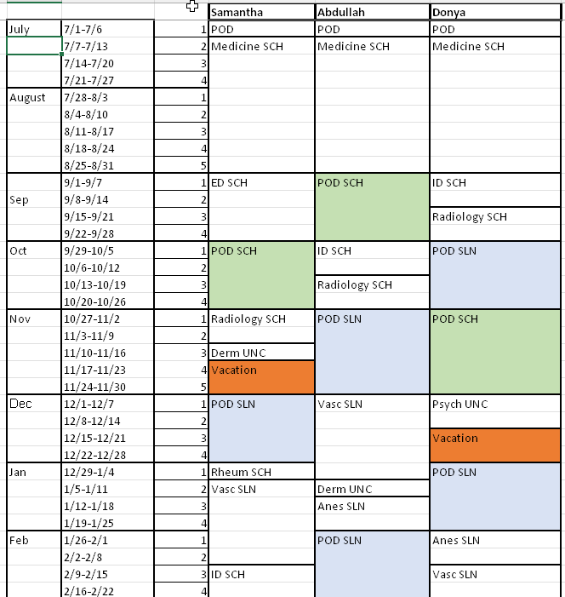
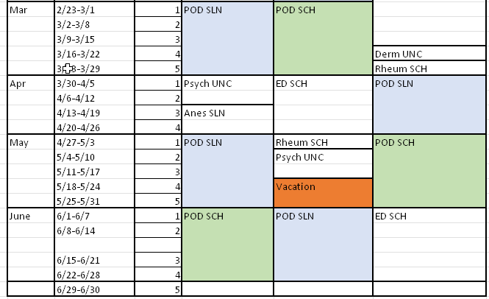
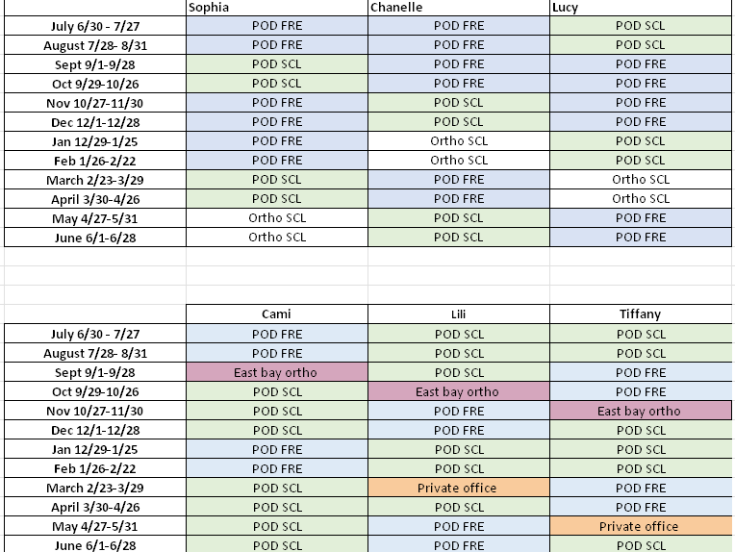

Rotations consisting of Internal Medicine, Infectious Disease, Rheumatology is equivalent to a minimum of three months.

Rotation | Name | Email | Phone number
Anesthesia SLN | Dr. Jason Lau | Jason.A.Lau@kp.org | 510-368-0176
Dermatology Union City | Dr. Lisa Hisaw  Cc Dr. Baran Ho | Lisa.D.Hisaw@kp.org  Baran.Ho@kp.org | 510-673-4482
Emergency Medicine SCL | Dr. Luz Silverio | Luz.m.silverio@kp.org | 408-482-9300
ID SCL | Dr. Ryan Knueppel | ryan.x.knueppel@kp.org | 669-600-7271
Internal Medicine SCL | Internal Medicine Chief Residents
Ortho SCL | Dr. Tung Le | Tung.B.Le@kp.org | 408-234-8648
POD GSAA Site Director | Dr. Jessica Lickiss | Jessica.lickiss@kp.org | 951-970-3000
Psych FRE | Dr. Rupinder Randhawa | Rupinder.X.Randhawa@kp.org | 510-598-0144
Radiology SCL | Dr. Craig McCormick | craig.m.mccormick@kp.org | 669-236-7489
Rheumatology SCL | Dr. Suresh Maharjan | Suresh.X.Maharjan@kp.org | 669-236-7310
Vascular Surg SLN | Dr. Joy Garg | Joy.x.garg@kp.org | 510-673-4806

Contact Information for Rotations 2024-2025
Santa Clara

Title | Name | Email | Phone number
Program Director | Dr. Cristian Neagu | Cristian.Neagu@kp.org | 669-600-7285
Residency Program Administrator | Pam Bautista | Pamela.bautista@kp.org | 408-851-3813

GSAA (San Leandro, Hayward, Union City, Fremont)

Title | Name | Email | Phone number
GSAA Lead Site Director | Dr. Jessica Lickiss | Jessica.lickiss@kp.org | 951-970-3000
GSAA (SLN, HAY, UNC, FRE) GME Program Manager | Toni Villasenor | Toni.Villasenor@kp.org | 925-786-3814

2025-2026 Academic Calendar

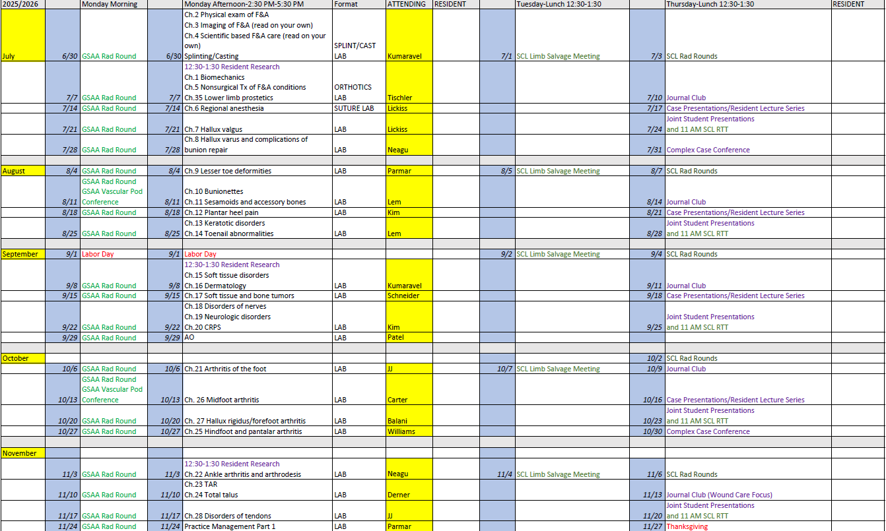
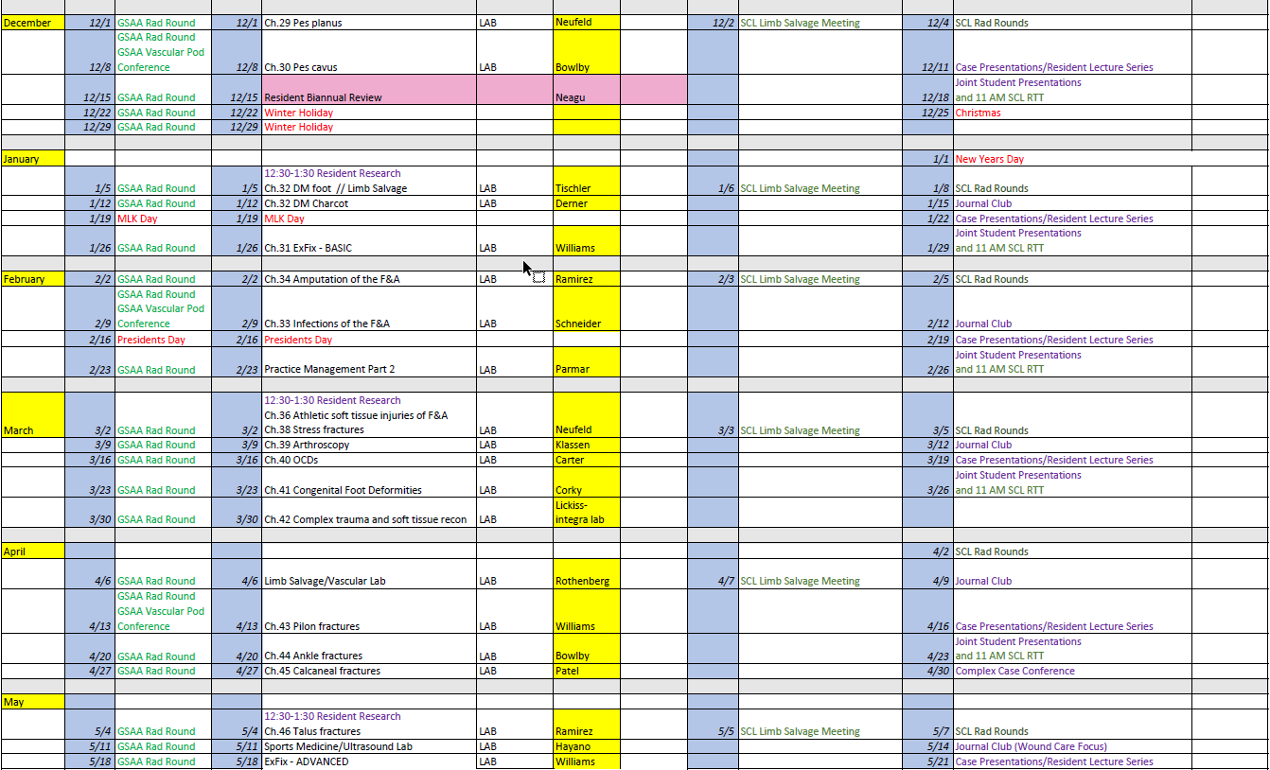
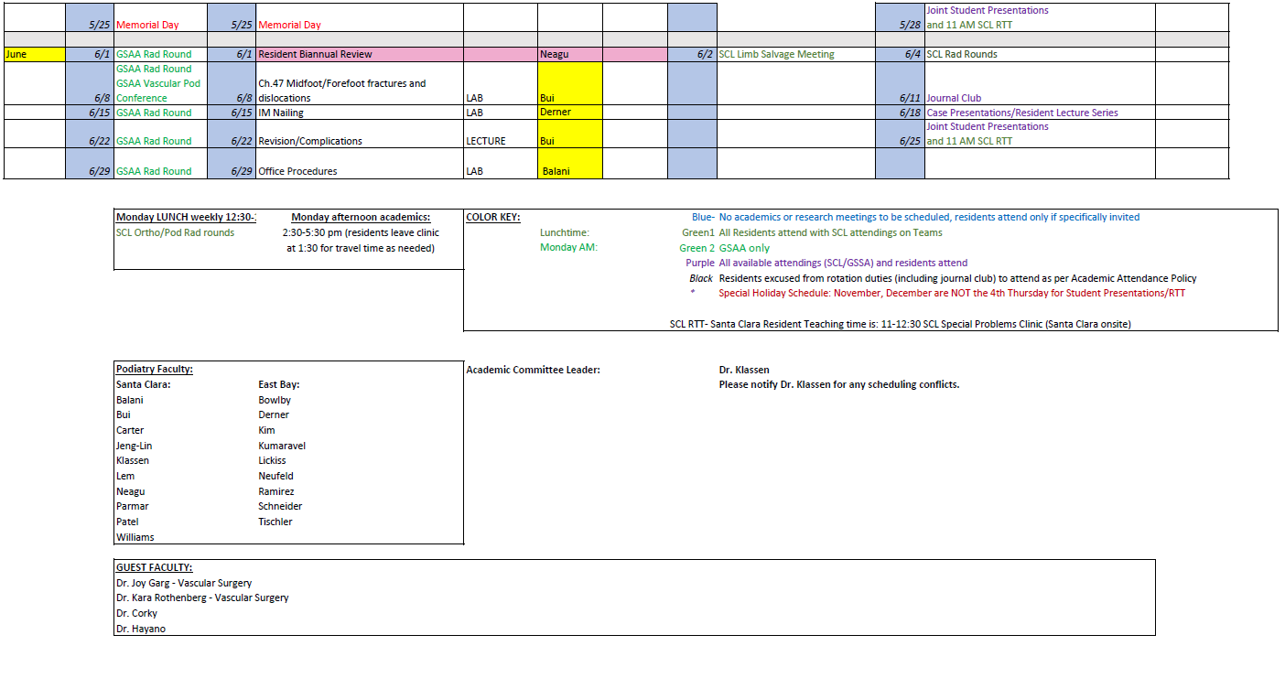

FOR LARGER VERSION PLEASE SEE KSC RESIDENCY ACADEMICS FOLDERS IN MICROSOFT TEAMS

JOURNAL REVIEW- takes place every 2nd Tuesday from 12:30 to 1:30 (see schedule above).

COMPETENCIES

Kaiser Foundation Hospital Santa Clara
Podiatric Surgical Residency
Anesthesia

Description and Goals:

A functional understanding of human anesthesia concepts in the setting of a suburban hospital is expected. The resident will work with a board-certified anesthesiologist and should understand and be involved in the treatment of pathology and indication for anesthesia consultation in both the inpatient and outpatient setting.
This is a two-week rotation.

Competencies:

Understands the components, techniques, and normal/abnormal of the history and physical examination pertinent to the pre-anesthetic assessment

Understands ASA Physical Status classification system and the impact of medical co- morbidities on preanesthetic assessment and management

Understands the pharmacology of pre-anesthesia medications (barbiturates, benzodiazepines, narcotics, anticholinergics)

Understands the pharmacology of neuromuscular blocking agents (depolarizing and nondepolarizing

Understands the pharmacology of the intravenous induction and maintenance agents

Understands the pharmacology of inhalational medications

Understands pertinent regional anatomy, including the airway

Understands the technical aspects of intubation, administration of spinal anesthesia and regional anesthesia (regional block anatomy/concepts)

Understands the management of allergies and adverse reactions to local anesthetics, epinephrine and preservatives

Understands the technical aspects of peri-anesthesia monitoring of a patient

Understands the workings and functions as a member of the anesthesia team.

Practices with professionalism, compassion and concern in a legal, ethical and moral fashion.

Kaiser Foundation Hospital Santa Clara
Podiatric Surgical Residency
Behavioral Medicine

Description and Goals:

A functional understanding of human behavioral medicine concepts in the setting of a suburban hospital is expected. The resident will work with a board-certified psychiatrist/psychologist and should understand and be involved in the treatment of pathology and indication for psychology/psychiatry consultation in both the inpatient and outpatient setting.

This is a one-week rotation.

Competencies:

Understand of the psychosocial aspects of health care delivery

Recognize and understand the manifestations and complications of common psychological medications

Understands and is able to recognize the basic manifestations of core psychological illnesses

Demonstrate an understanding of psychosocial and health care needs for patients in all life stages: pediatric through geriatric

Demonstrate sensitivity and responsiveness to cultural values, behaviors and preferences of one's patients when providing care to persons whose race, ethnicity, nation of origin, religion, gender and/or sexual orientation is/are different from one's own.

Demonstrate an understanding of public health concepts, health promotion and disease prevention.

Demonstrate ability to formulate a methodical and comprehensive treatment plan with appreciation of healthcare costs.

Appropriately manage and effectively refer the chronic pain patient

Understands the workings and functions as a member of the psychiatry/psychology team.

Practices with professionalism, compassion and concern in a legal, ethical and moral fashion.

Kaiser Foundation Hospital Santa Clara
Podiatric Surgical Residency
Dermatology

Description and Goals:

A functional understanding of human dermatology in the setting of a suburban hospital is expected. The resident will work with a board dermatologist and should understand and be involved in the treatment of cutaneous disorders and indication for dermatologic consultation in both the medical and the orthopedic setting.

This is a one-week rotation.

Competencies:

Demonstrates an appreciation for the epidemiology and pathophysiology of various cutaneous disorders.

Understands the basis for and application of laboratory, radiographic and other testing modalities.

Understands the basis for and application of different biopsy techniques.

Understands the basis for and application of topical and oral medications as they apply to the practice of dermatology.

Understands classifications and medical applications of topical and oral steroids as they apply to the practice of dermatology.

Understands the workings and functions as a member of the Dermatology department.

Kaiser Foundation Hospital Santa Clara
Podiatric Surgical Residency
Emergency Medicine

Description and Goals:

A functional understanding of human emergency medicine concepts in the setting of a suburban hospital is expected. The resident will work with a board-certified emergency room physician and should understand and be involved in the treatment of pathology and indication for emergency room consultation in both the inpatient and outpatient setting.

Competencies:

Demonstrates an appreciation for the epidemiology and pathophysiology of various pathology processes.

Obtains a comprehensive history and physical in adequate detail and in an appropriate period.

Understands when special diagnostic testing and consultation is appropriate

Understands the basis for and application of laboratory, radiographic and other testing modalities.

Recognizes the role of medical and surgical specialties in regard to appropriate consultation in emergent and non-emergent cases

Correctly obtained vital signs, draws blood for laboratory studies, interprets normal and abnormal lab values, establishes intravenous access and determines appropriate administration of tetanus prophylaxis.

Understands the workings and functions as a member of the emergency room team.

Formulate an appropriate differential diagnosis of the patient's diagnosis and formulates and implements an appropriate plan of care.

Practices with professionalism, compassion and concern in a legal, ethical and moral fashion.

Kaiser Foundation Hospital Santa Clara
Podiatric Surgical Residency
General and Vascular Surgery

Description and Goals:

A functional understanding of human anatomy and surgery concepts in the setting of a suburban hospital is expected. The resident will work with a board certified general/plastic surgeon and should understand and be involved in the treatment of general/vascular surgery pathology and indication for general and vascular surgery consultation in both the inpatient and outpatient setting.

This is a 5-week rotation.

Competencies:

Demonstrates an appreciation for the epidemiology and pathophysiology of various general/vascular surgery processes.

Appropriately examines/admits the patient in the preoperative and postoperative setting.

Appropriately examines/admits the patient in the emergency room setting.

Understands when special diagnostic testing and consultation is appropriate

Understands the basis for and application of laboratory, radiographic and other testing modalities.

Understands the workings and functions as a member of the general/vascular surgery team.

Understands principles of surgical operating techniques: tissue handling, principles of dissection, principles of suturing, principles of surgical dressings and materials.

Understands and is familiar with anatomy, local tissue blood supply/Angiosomes in association to surgical incision planning.

Understands and performs/interprets the findings of a comprehensive medical history and physical examination as it pertains to surgical patient.

Formulate an appropriate differential diagnosis of the patient's general medical problems and formulates and implements an appropriate plan of care.

Practices with professionalism, compassion and concern in a legal, ethical and moral fashion.

Kaiser Foundation Hospital Santa Clara
Podiatric Surgical Residency Program
Infectious Disease

Description and Goals
This is a two-week rotation in the medical offices, and hospitals at Kaiser Foundation Hospital, Hayward, and Fremont/ Santa Clara under the direction of board-certified infections disease physicians. Residents interact with the physicians and patients in an in-patient and out-patient setting.

A functional understanding of infectious disease in the setting of a suburban hospital is expected. The resident should understand the indication for an infectious disease consult in both the medical and orthopedic setting.

Competencies:

Demonstrates a functional understanding of the diabetic foot infection and likely infecting organisms.

Demonstrates a functional understanding of appropriate antibiotic therapy for a diabetic lower extremity infection.

Orders and appropriately interprets laboratory data to include blood cultures, gram’s stains, culture and sensitivity, and antibiotic monitoring.

Demonstrates the ability to interpret laboratory data, including CBC and ESR, blood cultures, gram stains, microbiological studies and antibiotic monitoring

Demonstrates a functional knowledge of gram negative and gram-positive organisms and the appropriate treatment for each.

Differentiates normal flora from pathogenic microbes

Identifies antimicrobial resistance based upon sensitivity results

Recognizes when test values indicate further history, physical exam, diagnostic studies or repeat/serial analysis.

Formulates an appropriate diagnosis or differential diagnosis.

Demonstrates a functional understanding of HIV infection and its implications in the orthopedic setting.

Demonstrates a functional understanding of C. Difficile infection and its implications in the hospital setting.

Kaiser Foundation Hospital Santa Clara
Podiatric Surgical Residency
Internal Medicine

Description and Goals:

A functional understanding of human internal medicine in the setting of a suburban hospital is expected. The resident will work with a board-certified internist and should understand and be involved in the treatment of internal medicine pathology and indication for internal medicine consultation in both the medical and the orthopedic setting.

Competencies:

Demonstrates an appreciation for the epidemiology and pathophysiology of various disease processes.

Appropriately examines/admits the patient in the primary care setting.

Appropriately examines/admits the patient in the emergency room setting.

Understands when special diagnostic testing and consultation is appropriate

Understands the basis for and application of laboratory, radiographic and other testing modalities.

Demonstrates the ability to perform and interpret the findings of a comprehensive medical history and physical examination.

Demonstrate ability to formulate an appropriate differential diagnosis of the patient's general medical problems.

Demonstrates the ability to formulate and implement an appropriate plan of management, when indicated, including appropriate therapeutic intervention, appropriate consultations and/or referrals and appropriate general medical health promotion and education.

Demonstrates the ability to perform procedure such as venipuncture, ABGs, thoracenteses as indicated under the supervision of chief resident/supervising physician.

Demonstrates sensitivity and responsiveness to cultural values, behaviors and preferences of one's patients when providing care to persons whose race, ethnicity, nation of origin, religion, gender and/or sexual orientation is/are different from one's own.

Understands the workings and functions as a member of the internal medicine team.

Kaiser Foundation Hospital Santa Clara
Podiatric Surgical Residency
Pathology

Description and Goals:

A functional understanding of human anatomy and pathology concepts in the setting of a suburban hospital is expected. The resident will work with a board-certified pathologist and should understand and be involved in the treatment of pathology and indication for pathology consultation in both the inpatient and outpatient setting.

This is a one-week rotation.

Competencies:

Demonstrates an appreciation for the epidemiology and pathophysiology of various pathology processes.

Understands when special diagnostic testing and consultation is appropriate

Understands the basis for and application of laboratory, radiographic and other testing modalities.

Understands the workings and functions as a member of the pathology team.

Understands principles of tissue processing, and bed inked, sectioned and staining.

Understands the distinctive features of benign versus malignant tumors and associated vascular studies which may be required to assist in reaching the correct diagnosis

Understands and is familiar with advantages and disadvantages of various biopsy techniques.

Understands, recognizes and correctly interprets the normal and abnormal microscopic features of the specimen.

Recognizes signs/indicators/markers of malignant processes.

Formulate an appropriate differential diagnosis of the patient's pathological diagnosis and formulates and implements an appropriate plan of care.

Practices with professionalism, compassion and concern in a legal, ethical and moral fashion.

Kaiser Foundation Hospital Santa Clara
Podiatric Surgical Residency
Plastic Surgery

Description and Goals:

A functional understanding of human anatomy and plastic surgery concepts in the setting of a suburban hospital is expected. The resident will work with a board-certified plastic surgeon and should understand and be involved in the treatment of plastic surgery pathology and indication for plastic surgery consultation in both the inpatient and outpatient setting.

This is a two-week rotation.

Competencies:

Demonstrates an appreciation for the epidemiology and pathophysiology of various plastic surgery processes.

Appropriately examines/admits the patient in the preoperative and postoperative setting.

Appropriately examines/admits the patient in the emergency room setting.

Understands when special diagnostic testing and consultation is appropriate

Understands the basis for and application of laboratory, radiographic and other testing modalities.

Understands the workings and functions as a member of the plastic surgery team.

Understands principles of surgical operating techniques: tissue handling, principles of dissection, principles of suturing, principles of surgical dressings and materials.

Understands and is familiar with local tissue blood supply/Angiosomes in association to surgical incision planning.

Understands and performs/interprets the findings of a comprehensive medical history and physical examination as it pertains to surgical patient.

Formulate an appropriate differential diagnosis of the patient's general medical problems and formal legs and implements an appropriate plan of care.

Practices with professionalism, compassion and concern in a legal, ethical and moral fashion.

Kaiser Foundation Hospital Santa Clara
Podiatric Surgical Residency
Podiatric Medicine and Surgery

Description and Goals:

A functional understanding of human podiatric medicine and surgery concepts in the setting of a suburban hospital is expected. The resident will work with a board-certified podiatrist and should understand and be involved in the treatment of pathology and indication for podiatric medicine and surgery consultation in both the inpatient and outpatient setting.

This is an ongoing rotation.

Competencies:

Performs a thorough problem-focused lower extremity history and physical exam, including problem-focused history, neurologic, vascular, dermatologic, and musculoskeletal examination.

Performs an appropriate biomechanical exam and assessment

Appropriately orders and interprets diagnostic tests and imaging studies, including plain radiography, radiographic contracts studies, stress radiography, fluoroscopy, nuclear medicine imaging, MRI, CT, diagnostic ultrasound, and vascular imaging.

Appropriately orders and interprets laboratory tests in hematology, serology/immunology, toxicology and microbiology, including blood chemistries, drug screens, coagulation studies, blood gases, synovial fluid analysis and urinalysis.

Secures proper patient positioning, performs skin incision appropriately, utilizes hemostasis appropriately, performs proper anatomic dissection, demonstrates appropriate tissue handling techniques, uses instrumentation appropriately, uses fixation/hardware appropriately and performs proper closure of the following: Digital Surgery: Arthroplasty, arthrodesis, tendon transfers, amputations.

Secures proper patient positioning, performs skin incision appropriately, utilizes hemostasis appropriately, performs proper anatomic dissection, demonstrates appropriate tissue handling techniques, uses instrumentation appropriately, uses fixation/hardware appropriately and performs proper closure of the following: Forefoot Surgery: First ray reconstruction/osteotomies Lesser ray reconstruction Joint fusions Neurectomy/nerve surgery soft tissue/tendon amputations

Secures proper patient positioning, performs skin incision appropriately, utilizes hemostasis appropriately, performs proper anatomic dissection, demonstrates appropriate tissue handling techniques, uses instrumentation appropriately, uses fixation/hardware appropriately and performs proper closure of the following: Rearfoot/Ankle Surgery: Joint fusions Arthroscopy Soft tissue/tendon Trauma/ORIF Osteotomies

Understands pertinent fixation materials, including physical characteristics, advantages/disadvantages, indications/contraindications and application

Understands pertinent graft materials, including physical characteristics, advantages/disadvantages, indications/contraindications, and application (autograft, allograft and synthetic graft bone, tendon, etc.).

Formulates a valid differential diagnosis for a variety of foot and ankle conditions.

Can offer appropriate conservative treatment to a variety of foot and ankle conditions when applicable, including pharmacologic therapy, footwear, taping, mobilization, physical therapy, and palliation.

Understands the workings and functions as a member of the podiatric medicine and surgery team.

Practices with professionalism, compassion and concern in a legal, ethical and moral fashion.

Kaiser Foundation Hospital Santa Clara
Podiatric Surgical Residency
Radiology

Description and Goals:

A functional understanding of human radiology in the setting of a suburban hospital is expected. The resident will work with a board-certified radiologist and should understand and be involved in the radiographic interpretation of pathology and indication for radiologic consultation in both the medical and the orthopedic setting.

This is a one-week rotation.

Competencies:

Demonstrates an appreciation for the epidemiology and pathophysiology of various radiographic presentation of medical disorders.

Understands the general principles of radiation physics and safety

Understands normal and abnormal findings on plain radiographic views

Understands the rationale for ordering the following nuclear medicine studies: Tc99 bone scan, gallium scan, indium scan, V/Q scan, thallium perfusion scan

Understands the basis for and application of laboratory, radiographic and other testing modalities.

Understands the basis for and application of different radiographic techniques.

Understands various techniques of MRI imaging in regard to anatomy and pathology. Correctly distinguishes between different MRI studies, including but not limited to: T2 weighted, T1 weighted, STIR, proton density, and gradient echo images

Understands the basis for and application of radiographic studies as they apply to the practice of medicine, orthopedics, and podiatry.

Appropriately performs stress fluoroscopic examinations

Understands the workings and functions as a member of the Radiology department.

Demonstrates ability to formulate a methodical and comprehensive treatment plan with appreciation of health care costs.

Kaiser Foundation Hospital Santa Clara
Podiatric Surgery Residency Program
Rheumatology

Description and Goals
This is a two-week rotation in the medical offices at Kaiser Foundation Hospital, Hayward/Santa Clara under the direction of a board-certified rheumatologist.

The goal of this rotation is to educate the resident in the diagnosis and management of seropositive and seronegative inflammatory disorders of joints and other tissues. Understanding the indication for rheumatology referral is an important goal.

Competencies:

Demonstrates a functional understanding of the anatomy and physiology of the normal joint.

Demonstrates a functional understanding of the pathophysiology, and morbidity of the various types of arthritis, collagen vascular disease and related immune diseases.

Demonstrates the ability to diagnose various types of arthritis, collagen vascular disease and related immune disease

Demonstrates a functional understanding of the management of arthritis and related disease in the primary care setting.

Formulate an appropriate differential diagnosis of the patient's rheumatological problems. *

Understands the importance of interdisciplinary aspects of arthritis management.

Demonstrates an appreciation for the place of musculoskeletal surgery in the management of inflammatory disease.

Understands the workings and functions as a member of the orthopedic surgery team.

Practices with professionalism, compassion, and concern in a legal, ethical and moral fashion.

Kaiser Foundation Hospital Santa Clara
Podiatric Surgical Residency
Orthopedic Surgery

Description and Goals:

A functional understanding of human orthopedic medicine and surgery concepts in the setting of a suburban hospital is expected. The resident will work with a board-certified orthopedic surgeon and should understand and be involved in the treatment of pathology and indication for orthopedic surgery consultation in both the inpatient and outpatient setting.

This is an 8-week rotation.

Competencies:

Performs a thorough problem-focused history and physical exam, including problem-focused history, neurologic, vascular, dermatologic, and musculoskeletal examination.

Performs an appropriate biomechanical exam and assessment

Appropriately orders and interprets diagnostic tests and imaging studies, including plain radiography, radiographic contracts studies, stress radiography, fluoroscopy, nuclear medicine imaging, MRI, CT, diagnostic ultrasound, and vascular imaging.

Appropriately orders and interprets laboratory tests in hematology, serology/immunology, toxicology and microbiology, including blood chemistries, drug screens, coagulation studies, blood gases, synovial fluid analysis and urinalysis.

Secures proper patient positioning, performs skin incision appropriately, utilizes hemostasis appropriately, performs proper anatomic dissection, demonstrates appropriate tissue handling techniques, uses instrumentation appropriately, uses fixation/hardware appropriately and performs proper closure of the following: trauma, Arthroplasty, arthrodesis, tendon transfers, amputations, microvascular surgery, osteotomies.

Understands pertinent fixation materials, including physical characteristics, advantages/disadvantages, indications/contraindications and application

Understands pertinent graft materials, including physical characteristics, advantages/disadvantages, indications/contraindications, and application (autograft, allograft and synthetic graft bone, tendon, etc.).

Formulates a valid differential diagnosis for a variety of orthopedic conditions.

Can offer appropriate conservative treatment to a variety of orthopedic conditions when applicable, including pharmacologic therapy, footwear, taping, mobilization, physical therapy, and palliation.

Understands the workings and functions as a member of the orthopedic surgery team.

Practices with professionalism, compassion and concern in a legal, ethical and moral fashion.

